Networking Fundamentals
by Viktor Grozdev

- Network
1.1. Protocols
At the simplest level if two computers want to exchange data they will need rules so both could understand each other. Those rules are called protocols.
1.2. Network Layers
Networks are split into layers. Each layer is responsible for a specific thing. Tools like nmap are targeting specific layers. Each layer is very different compared to others. And each layer trusts the one below it.
HTTP doesn’t care how packets travel
TCP doesn’t care what data is inside
IP doesn’t care what service it’s for
Vulnerabilities exist when layers trust each other too much.
envelope ≠ letter content ≠ language
1.3. IP
IP serves for routing, not communication logic. The IP address only answers “Where should this packet go?”. It does not identify the user, the program or guarantee delivery.
Example: Packet has a destination IP:192.168.1.10 . Routers forward it until it reaches that machine.

What is an IP Header?
This is where routing happens.
An IP header is the control information at the beginning of an Internet Protocol (IP) packet, acting like a digital shipping label that guides data across networks, containing essential metadata like source/destination IP addresses, packet length, version (IPv4/IPv6), Time-to-Live (TTL), and protocol type, ensuring it reaches its correct destination efficiently.

What is TTL (Time to Live)?
TTL is a value that controls how long data (like network packets or DNS records) should exist before being discarded or refreshed, preventing endless loops and managing network traffic efficiently.

1.4. Ports (Open/Closed)
Inside ONE computer many programs listen for data. The OS (operating system) needs a way to decide which program gets that data. And that's the port.

For example:
A port number ranges from 0 to 65535.
Each listening program binds to a specific port.
-> Web server listens on port 80
-> SSH server listens on port 22
Packet arrives at the right IP (Destination) and at the right program (Port).
If no program is listening on that program the OS returns
RST (reset). This is how we detect closed ports.

1.5. TCP
TCP (Transmission Control Protocol) is a core internet protocol ensuring reliable, ordered, and error-checked delivery of data between applications, forming the backbone of the TCP/IP suite for web, email, file transfers, etc., by breaking data into packets, managing connections (three-way handshake), confirming receipt, and handling congestion for accurate communication.

What is a TCP Header?
This defines the connection behavior.
Contains:
- Source port
- Destination port
- Sequence number
- Acknowledgment number
- Flags

TCP Flags:
- SYN – start connection
- ACK – acknowledge data
- RST – reset connection
- FIN – close connection
- PSH – push data immediately
Port scanning = manipulating these flags.
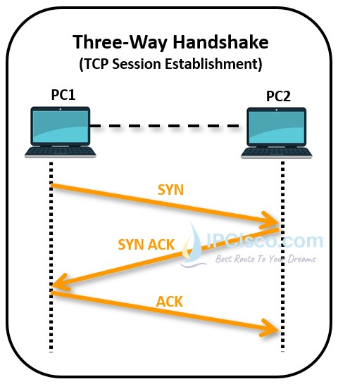

In the picture on the right we can see the TCP three-way handshake.

- SYN (Synchronize) is the first step to establishing a reliable connection between a client and a system.

- SYN-ACK (Synchronize-acknowledgment) is the second step where the server responds to the client’s SYN request with a single packet that has both the SYN and ACK flags set. Confirming receipt of the client's SYN and offering its own sequence number to establish a reliable, full-duplex connection before data transfer begins.
- ACK (Acknowledgement) in this third and final step the client sends a final ACK packet to the server, confirming it received the server's SYN-ACK, thereby establishing a reliable, synchronized connection ready for data transfer. It's the "I got your message, let's talk" confirmation that completes the connection setup.

1.6. UDP (User Datagram Protocol)
UDP is a communication protocol used across the Internet for especially time-sensitive transmissions such as video playback or DNS lookups.

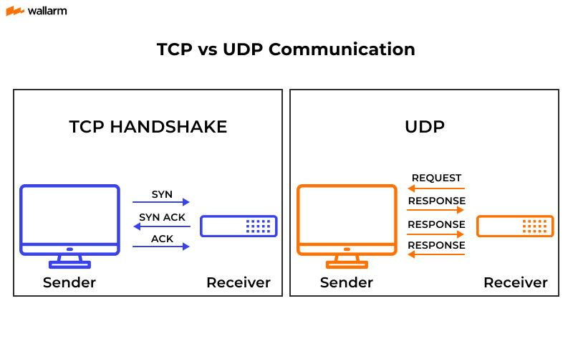
What is an example of UDP?
Streaming media, real-time multiplayer games and voice over IP (VoIP) are examples of applications that often use UDP.

1.7. Packets
A packet is the smallest unit of data that can be sent over a network. Computers never send entire files at once. Instead they send small pieces of data (packets) separately. Why? Because networks are unreliable and routers can drop data.
-> The Internet does not send messages - it sends packets.

Why do packets exist?
Imagine if you have to send a 100 MB file. If only one 1 bit gets lost the whole file is corrupted. Packets solve this issue by sending data over into manageable sizes, letting routers forward data efficiently and allowing retransmission of only missing pieces.

What is a packet made of?
A packet has two main parts.

- Header (control information)
This tells the network what to do with the packet.
- Payload (actual data)
This is the real content of the packet. It can contain part of a webpage, command, passwords, etc.

Hackers mostly abuse headers, not payloads.

Application Data (Payload):
This is where:
- HTTP requests live
- SSH commands live
- Login credentials live
Example payload:

GET /admin HTTP/1.1

Host: example.com

How do packets actually travel?

Let’s say you open a website.

Step 1: The application creates data
Your browser generates an HTTP request.
Step 2: TCP splits data
It breaks data into segments and then numbers them (sequential numbers).

Step 3: IP wraps it 🎁
The IP adds source and destination IP and then decides where to send it.

Step 4: Ethernet sends it. 📩
Network hardware sends bits over wire or Wi-Fi.
Every router reads the IP Header and forward packets closer to the destination.

What packets mean for hacking?
Every tool you use:
- Crafts packets
- Sends packets
- Analyzes responses

Examples:
- Nmap → sends packets with special TCP flags
- Gobuster → sends thousands of HTTP packets
- Hydra → replays authentication packets
- Metasploit → sends exploit payloads inside packets
If you understand packets:
- You can predict tool behavior
- You can spot false positives
- You can bypass defenses

Firewalls and packets:
Firewalls inspect and filter network traffic, which travels in packets, by examining packet headers (source/destination IP, port, protocol) against predefined rules to decide whether to allow or block them, protecting networks from unauthorized access by acting as a digital gatekeeper.
Example:
- Too many SYN packets → scan detected
- Invalid flags → suspicious traffic
This is why stealth scans exist.

